Agent
→ It is an autonomous software that can think or understand its environment, make decisions, and take actions, often using reasoning.
Or
→ A system or program that is capable of performing tasks autonomously.

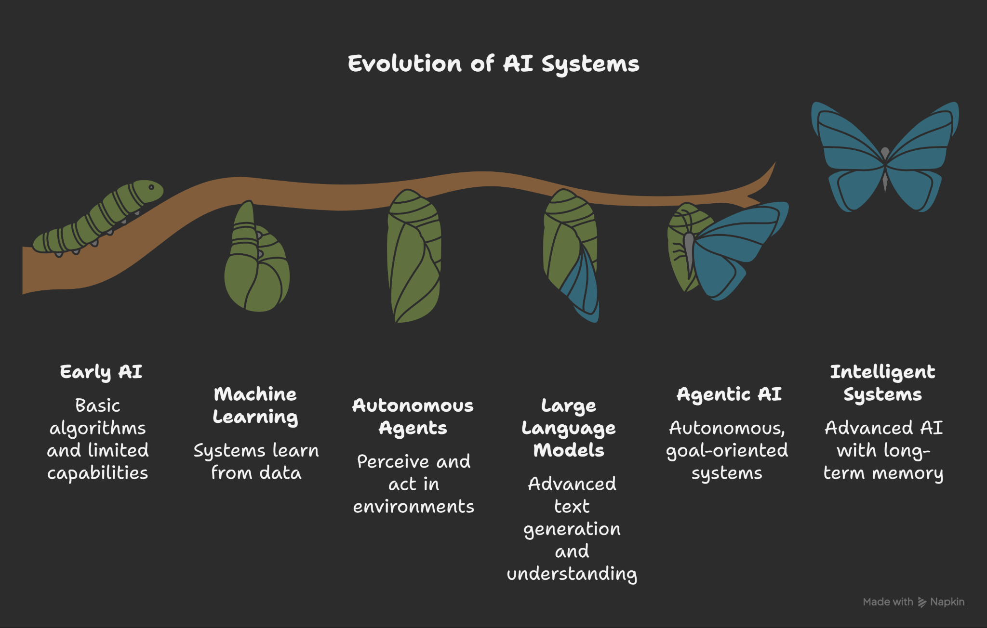

Time line of ML vs Agent Vs LLM

Year / Decade | Machine Learning (ML) | Agents (AI / Software / Multi-Agent Systems) | Large Language Models (LLMs)
1940s–1950s | – 1943: McCulloch & Pitts propose neural net models. – 1949: Hebb introduces foundational learning theory. – 1951: SNARC, the first learning neural network built by Minsky & Edmonds. – 1952: Samuel’s self-learning checkers program demonstrates a learning system. – 1959: Arthur Samuel coins “Machine Learning” to describe systems learning without explicit programming. | – — | – —
1960s | – 1967: Nearest Neighbor algorithm introduced. – Early pattern recognition and neural network exploration. | – 1966–72: Shakey the Robot — first mobile, perceptive, planning agent . | – 1966: ELIZA, the first chatbot (rule-based conversation), early precursor to LLMs.
1970s | – 1970s: Backpropagation concept emerges (Linnainmaa’s work on automatic differentiation). – 1976: Concept of transfer learning introduced. | – 1977: Actor Model by Carl Hewitt introduces the idea of autonomous, message-passing agents — early concept of "agent" in CS. | – —
1980s | – 1986: Rumelhart, Hinton & Williams popularize Backpropagation, reviving neural network research. | – 1980s: John McCarthy describes AI systems as agents that perceive and act. Emergence of expert systems framed as “knowledge-based agents”. | – —
1990s | – 1995: Support Vector Machines (SVMs) introduced. – 1998: LeNet-5 CNN by LeCun enables digit recognition. | – 1995: Russell & Norvig formalize the agent paradigm — “agent = perceiver + actor.” – 1996: Franklin & Graesser published taxonomy “Agent vs. Just a Program?”. | – 1997: LSTM introduced, crucial for sequence modeling.
2000s | – Early 2000s: Adoption of kernel methods, recommender systems. – 2006: Hinton coins Deep Learning concept with deep belief networks. | – 2000s: Rise of interface agents and recommender systems (Maes’s work at MIT). | – —
2010s | – 2012: AlexNet wins ImageNet — deep learning explosion. – 2013: Word2Vec introduces word embeddings. – 2014: GANs invented. – 2015: ResNet enables deeper CNNs. – 2016: AlphaGo demonstrates autonomous RL agents — major AI milestone. | – Agents increasingly incorporate learning and perception, especially in robotics and simulations. – Multi-Agent Reinforcement Learning (MARL) gains traction. | – 2017: Transformers introduced via “Attention Is All You Need” — revolution in NLP. – 2018: GPT-1 and BERT launched — generative vs. understanding paradigms.
Late 2010s – 2020 | – 2020: Explosion of pre-trained models and scale. | – 2020–22: Agents start integrating LLMs—e.g., Codex for code agents. | – 2019: GPT-2 released. – 2020: GPT-3 (175B parameters) lands a breakthrough in general-purpose generative AI.
2021–2022 | – Growth in multimodal ML—combining text, image, audio. | – Agents evolve into LLM-powered frameworks — e.g., Codex, early prototypes of autonomous agents. | – 2022: ChatGPT launches—popularizing conversational LLMs.
2023 | – RLHF, tool-use, agentic reasoning incorporated in ML architecture. | – 2023: Frameworks like AutoGPT, LangChain, BabyAGI enable autonomous LLM-agent chaining. | – 2023: GPT-4, Gemini, Claude, LLaMA released—advancing multimodality.
2024–2025 | – Emphasis on retrieval-augmented generation (RAG), efficient scaling, multimodal integration. | – Rise of multi-agent LLM ecosystems—swarm AI for real-world tasks. | – 2025: Continued evolution of LLMs (e.g., improved models like GPT-5).

Machine Learning (ML): This is a broad field of AI focused on enabling systems to learn from data without explicit programming. ML encompasses various algorithms and techniques, such as supervised learning, unsupervised learning, and reinforcement learning, used to build predictive models, classify data, or discover patterns. LLMs and AI Agents are specific applications or architectures built upon ML principles.

Large Language Model (LLM): An LLM is a type of machine learning model, specifically a deep learning model, trained on vast amounts of text data. Its primary function is to understand, generate, and process human language. LLMs excel at tasks like text generation, summarization, translation, and question answering, based on the patterns and knowledge learned during their extensive training.
Training data
LLM
Promt
Response
LLM

Retrieval-Augmented Generation (RAG): RAG is an architectural pattern that enhances the capabilities of LLMs. It addresses the limitation of LLMs only being able to access information present in their training data. RAG systems augment LLM responses by first retrieving relevant information from external knowledge sources (like databases, documents, or the internet) and then using that retrieved information to inform the LLM's generation process. This leads to more accurate, up-to-date, and contextually relevant responses, especially for specific or evolving information.

Training Data
LLM
External data source
Promt
output
RAG
AI Agent: An AI Agent is a more autonomous and goal-oriented system than a standalone LLM. While an LLM can be a core component of an AI agent, an agent also incorporates mechanisms for perceiving its environment, planning actions, utilizing tools (including LLMs and external APIs), and executing those actions to achieve a specific objective. Agents can maintain memory of past interactions and adapt their behavior over time, making them suitable for complex, multi-step tasks requiring interaction with the real world or other systems.

Agent
LLM
External source
Training Data
Promt
Internet tools
Api
Response

Agent

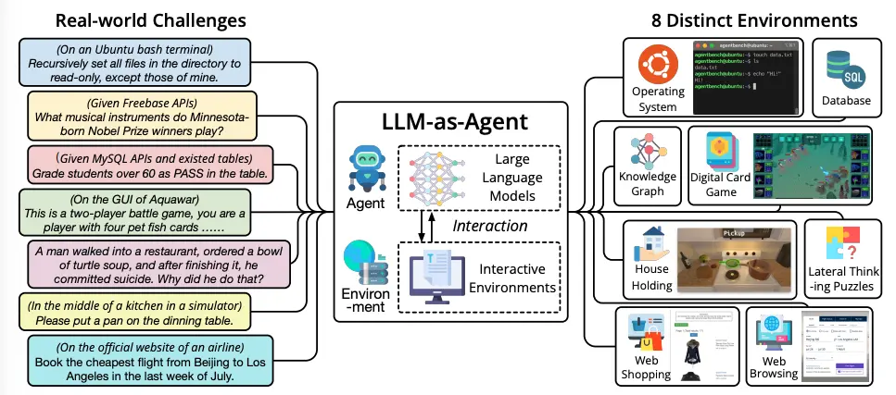

How Agents differ from RAG and LLM?
LLMs are language models, RAG (Retrieval-Augmented Generation) augments an LLM with external knowledge, and Agents are autonomous systems that use LLMs, tools, and external knowledge (often via RAG) to plan, make decisions, and perform actions in the real world to achieve a goal. In essence, LLMs are the "brain," RAG provides an "enhanced library," and Agents combine the brain and library with the ability to "act".

In what ways are AI agents more useful to the user compared to standalone LLMs and RAG systems?
Agent offer greater autonomy, goal-directed behavior, and real-world interaction through dynamic tool usage and memory. Unlike passive LLMs or RAG systems that primarily provide information, AI agents can reason, plan multi-step workflows, use external tools, and take action to achieve complex, long-term goals with reduced human intervention.

Types of AI Agents & Their Evolution

1. Simple Reflex Agents
- Description: Act based solely on current percepts using predefined condition-action rules.
- Why coined: To model systems that respond immediately without internal memory or reasoning.
- Example: Thermostats turning the heater on/off.

2. Model-Based Reflex Agents
- Description: Maintain an internal representation of the world to handle partially observable environments.
- Why coined: To overcome limitations of reflex agents by allowing memory-based responses.
- Example: Robot vacuums mapping rooms to avoid repetition.

3. Goal-Based Agents
- Description: Decide actions aimed at achieving specific goals, using planning/search strategies.
- Why coined: To model rational, goal-directed behavior beyond simple reaction.
- Example: Chess-playing AI planning moves toward checkmate.

4. Utility-Based Agents
- Description: Use a utility function to weigh multiple outcomes and choose actions that maximize overall benefit.
- Why coined: To handle preferences, trade-offs, and uncertainty effectively.
- Example: Self-driving cars optimizing route based on safety and efficiency.

5. Learning Agents
- Description: Improve their behavior over time by learning from past experiences.
- Why coined: To enable agents to adapt and operate autonomously in dynamic environments.
- Example: Recommender systems evolving based on user interactions.

6. Deliberative (Intentional) Agents
- Description: Possess symbolic models of the world, utilizing reasoning and planning (BDI: Belief–Desire–Intention architecture).
- Why coined: To support agents capable of thoughtful, plan-based action in complex domains.
- Example: Systems that replan strategies in dynamic simulations.

7. Embodied Agents
- Description: Agents that exist with a physical or virtual body, interacting using gesture, speech, or movement.
- Why coined: To model human-like, socially engaging AI interactions.
- Example: Virtual assistants with human-like avatars.

8. Mobile Agents
- Description: Software agents capable of migrating autonomously between networked environments holding their state and code intact.
- Why coined: To enable computation closer to data, improving flexibility, efficiency, and fault tolerance in distributed settings.
- Example: Telescript-based mobile agents moving across servers.

9. Monitoring & Surveillance Agents
- Description: Specialized agents that continuously observe systems or networks and act upon detecting anomalies or state changes.
- Why coined: To automate proactive oversight in network and system administration.
- Example: Network monitoring tools alerting for configuration changes or failures.

10. Multi-Agent Systems (MAS)
- Description: Systems where multiple agents interact—cooperatively or competitively—to perform complex tasks.
- Why coined: To model decentralized, distributed intelligence and coordination.
- Example: Teams of robots collaborating in manufacturing systems.

11. Hierarchical Agents
- Description: Agents organized across multiple levels, where higher-level agents coordinate lower-level agents.
- Why coined: To break down complex tasks into structured subtasks, improving manageability in large systems.
- Example: AutoGPT framework using a high-level controller and specialized subagents.

